The US Fish and Wildlife Service- EPP Proposal
Written by: Roy Rashke
Executive Summary
The US FWS was originally established to protect the environment at large in a very broad sense. The Endangered Animal Species Program was put into place by Congress. Congress passed the Endangered Species Act (ESA) in 1973, this was due to the inherent concern for the nation's native plants and animals that were in danger of becoming extinct. With the passing of the ESA in 1973, Congress sought to enhance the protections of animals under the Endangered Species Preservation Act (ESPA) of 1966. The ESPA in 1973 also authorized the FWS to acquire land as habitat for endangered species as well as an international meeting to adopt a convention to conserve endangered species. With the convention convened the FWS was able to adopt their mission statement of
“Our mission is to work with others to conserve, protect and enhance fish, wildlife and plants and their habitats for the continuing benefit of the American people.”
The primary point of the US Fish and Wildlife Service is to preserve the natural world for plants, animals and humans. This includes listing species on protection lists and acquiring land for their safe living conditions. When referring back to the original legislation that created the FWS endangered animal program, one can see the original purpose was much more specific as it stated,
“The purpose of this act is to provide a means whereby the ecosystems upon which endangered species and threatened species depend may be conserved, to provide a program for the conservation of such endangered species and threatened species, and to take such steps as may be appropriate to achieve the purposes of the treaties and conventions set forth in the overview of the US Fish and Wildlife Service”
As seen above, the changes from the original purpose of the endangered animal act to current missions involve the additional protections offered with subsequent law passings. This opened opportunities to expand efforts, including broader habitat protections, protected species and conservation efforts. At its inception the FWS has approximately 216 officers compared to their current number of 345 officers. The 345 current field officers in the FWS agency provide enforcement through criminal fines, civil penalties, prison sentences or probation sentences. In the most recent report from the Department of Interior, officers in the last four years have issued approximately $6.025 million in fines, $1.45 million in civil penalties, 51 years of prison sentences, and 296 years of probation sentences on average every year. This data is for all 45 of enforcement hubs across the US which include the top ten busiest ports of entry which are New York, Los Angeles, Newark, Louisville, Miami, Memphis, Chicago, Dallas, San Francisco, and Honolulu.
Program History
The US Fish and Wildlife Service has a long extensive history dating back to the 1870s. The FWS started as the Commission on Fish and Fisheries and eventually expanded to what it is today. The history of the Fish and Wildlife protection act programming will be outlined below from 1956 to the most recent activities:
1956:
The Fish and Wildlife Act of l956 established a comprehensive national fish and wildlife policy and broadened the authority for acquisition and development of refuges.
The Fish and Wildlife Service re-organized into the United States Fish and Wildlife Service consisting of the Bureau of Sport Fisheries and Wildlife and Bureau of Commercial Fisheries.
1960:
Arctic National Wildlife Range established
1964:
Congress passes the Land and Water Conservation Fund and provides a dedicated funding stream for land acquisition.
Wilderness Act creates National Wilderness Preservation System which includes national wildlife refuges.
1966:
Congress passes the National Wildlife Refuge System Administration Act for the administration and management of all areas in the system including "wildlife refuges, areas for the protection and conservation of fish and wildlife that are threatened with extinction, wildlife ranges, game ranges, wildlife management areas, and waterfowl production areas."
1967:
Bald eagles declared an endangered species
1969:
The National Environmental Policy Act (NEPA) passed by Congress and becomes the principle tool for assessing the impacts of major federal development projects on fish and wildlife.
1970:
The Endangered Species Conservation Act of 1969 became effective prohibiting the importation into the United States of species "threatened with extinction worldwide," except as specifically allowed for zoological and scientific purposes, and propagation in captivity.
Bureau of Commercial Fisheries is moved out of the U.S. Fish and Wildlife Service and transferred to Department of Commerce, renamed National Marine Fisheries Service as part of new National Oceanic and Atmospheric Administration.
The peregrine falcon is listed as endangered, a victim of the pesticide DDT, which caused eggshell thinning and prevented breeding success
1972:
The Environmental Protection Agency bans the use of DDT in the U.S. because of its potential danger to both people and to wildlife, including the bald eagle, peregrine falcon, and brown pelican.
U.S. and Japan signed the Convention for the Protection of Migratory Birds and Birds in Danger of Extinction, and Their Environment. The Convention addresses the conservation of migratory birds in the U.S., its territories, and Japan.
The Marine Mammal Protection Act was enacted, prohibiting the take (i.e., hunting, killing, capture, and /or harassment) of marine mammals, and enacting a moratorium on the import, export, and sale of marine mammal parts and products.

1973:
Congress passes the Endangered Species Act and puts Fish and Wildlife Service and National Marine Fisheries Service in charge of enforcing it. Over 25 refuges have been established for the specific protection of an endangered species, including the Attwater Prairie Chicken, Mississippi Sandhill Crane, and Crocodile Lake Refuges.
1975:
The Convention on International Trade in Endangered Species of Wild Fauna and Flora (CITES) is ratified, regulating the importation, exportation, and re-exportation of species.
1976:
Convention Between the U.S. and the USSR Concerning the Conservation of Migratory Birds and Their Environment, signed in Moscow on November 19, 1976. The Convention provides for the protection of species of birds that migrate between the United States and the Soviet Union or that occur in either country and "have common flyways, breeding, wintering, feeding or moulting areas."
1977:
The first plant species are listed as endangered—the San Clemente Island Indian paintbrush, San Clemente Island larkspur, San Clemente Island broom, and San Clemente Island bush-mallow.
1978:
The U.S. Supreme Court finds the Tennessee Valley Authority in violation of the ESA by building a dam that would threaten the continued survival of the snail darter.
The U.S. Supreme Court finds the Tennessee Valley Authority in violation of the ESA by building a dam that would threaten the continued survival of the snail darter.
1980:
Congress passes the Alaska National Interest Lands Conservation Act, creating 9 new wildlife refuges including the 18 million acre Arctic National Wildlife Refuge, and expanding 7 other units. The law adds 54 million refuge acres in Alaska, tripling the size of the Refuge System.
Fish and Wildlife Conservation Act enacted protecting non-game species.
1984:
National Fish and Wildlife Foundation Establishment Act creates the Foundation as a federally chartered charitable, non-profit corporation to aid Service conservation efforts.
1985:
Animal Damage Control moved from Fish and Wildlife Service to the Animal and Plant Health Inspection Service in United States Department of Agriculture.
1988:
The African Elephant Conservation Act became law, providing additional protection for the species, whose numbers had declined by 50 percent in the last decade. The Lacey Act was amended to include, among other things, felony provisions for commercial guiding violations.
1995:
Bald eagle upgraded from endangered to a threatened species.
1997:
National Wildlife Refuge System Improvement Act strengthens the mission of the Refuge System, clarifies priority public uses, and requires comprehensive conservation plans for every refuge.
The National Conservation Training Center in Shepherdstown, West Virginia is officially dedicated.
1998:
Reauthorization of the Rhinoceros-Tiger Conservation Act prohibited the import, export, or sale of any product, item or substance containing, or labeled as containing, any substance derived from tigers or rhinos.
1999:
The peregrine falcon delisted following recovery.
2000:
Congress passes the Neotropical Migratory Bird Conservation Act to protect and conserve neotropical migrants both in the U.S. and in their winter homes in latin America and the Caribbean.
2004:
The California Condor reproduces in the wild for the first time in 17 years.

2007:
As a result of the banning of DDT and ESA protection, the bald eagle is delisted due to recovery.
2009:
Three additional marine national monuments were established in the Pacific. In total, these 4 marine monuments protect the biological and geological heritage on nearly 214,777,000 acres of small islands, atolls, coral reefs, submerged lands, and deep blue waters.
As a result of the banning of DDT and ESA protection, more than 650,000 brown pelicans could be found across Florida and the Gulf and Pacific Coasts. Therefore, it is removed from Federal protection as an endangered species.
2010:
On April 20, the Deepwater Horizon drilling rig exploded and sank in the Gulf of Mexico, triggering the largest oil spill in history. Oil gushed from the sea floor until the well was capped on July 15. About 4.9 million barrels of oil are estimated to have been spilled during these 87 days. During the response and continuing in the damage assessment FWS employees worked to rescue oiled wildlife, patrol beaches, wetlands, and estuaries, relocate sea turtles, assist the States and local landowners, and evaluate the ecological impacts of the spill.
2013:
On November 14, 2013, the United States destroyed its six‐ton stock of confiscated elephant ivory, sending a clear message that the nation will not tolerate wildlife crime that threatens to wipe out the African elephant and a host of other species around the globe.
The destruction of this ivory, which took place at the U.S. Fish and Wildlife Service’s National Wildlife Property Repository on the Rocky Mountain Arsenal National Wildlife Refuge near Denver, Colorado, was witnessed by representatives of African nations and other countries, dozens of leading conservationists, and international media representatives.
2014:
On February 5, 2014, the U.S. Fish and Wildlife Service proposed delisting the Oregon chub from the Endangered Species Act. If finalized, it would be the first ever fish removed from the ESA due to recovery, a monumental success for the Service and the many partners who worked together to make this happen, and for all Americans concerned about the health of our nation’s wildlife.
Changes to policy come with the listing and delisting of animals. The chart below shows the criteria for listing an animal or plant as either Vulnerable, endangered or extinct. The status of animals and plants change throughout the years so it is vitally important for the FWS to keep up to date on the number of mature individuals of a species there are.
Different political leaders have enacted different legislation to ether increase or decrease the agencies powers. Economic factors have not stopped the FWS. The current budget includes 1.5 billion in permanent appropriations and another 1.4 billion in yearly allocated funds for 2.8 billion total. Environmental factors are the most critical factors to change the way the FWS operates. As the environment changes so do animals and their status, their habitats and the FWS ability to preserve delicate and specific natural habitats
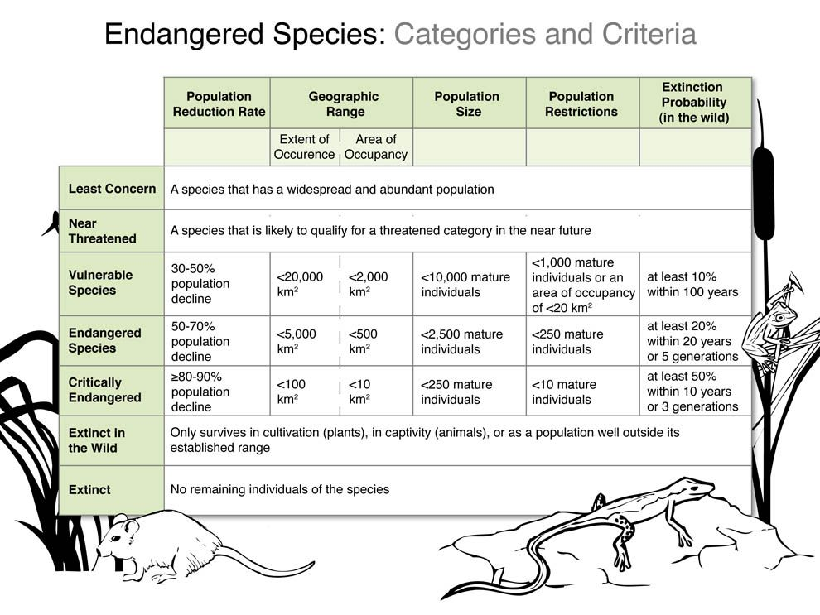

Stakeholders and Setting
The outside factors affecting the US FWS programs both directly and indirectly include whether the animal and plant food chains are staying intact. If a food chain is disrupted by an extinction of a species that could essentially disrupt the whole ecosystem and throw off balance the cycles in the wild. The second factor is the reproductivity safety of the endangered or threatened animals. Just because the land an animal frequents or lives on is protected land doesn’t mean it is safe from animal predators or have safe conditions to reproduce at the levels to remove them from listing. The third factor deals with the levels of extinctions over the years. These factors can be directly linked to the outcomes, both positive and negative, of the FWS programs. Lastly, the amount of land in a protected status is a major factor.
These factors can lead to challenges in funding, staffing, policy and even disbanding of programming. Factors that lead to challenges can be either supported or opposed depending on the party involved.
Those parties that are opponents for advancement in the US FWS endangered animal protection programs include: Farmers, Hunters/ Fishers, and Republicans. Farmers would oppose advancement due to increased scrutiny from the government and a potential increase in costs for high cost equipment and products to complete their farming tasks, hunters/fishers would be impacted by additional policies and decreases in allowable hunting of species, lastly, Republicans would be opposed to conserve nature through governmental regulations.
Those parties that are supporters for advancement in the US FWS endangered animal protection programs include: Animals, Congress, Democrats and FWS Employees. Animals would support any advancement in the FWS because they are the ones directly impacted as several species are either threatened or endangered, Congress at large have both parties who want to conserve nature, this is where Democrats come to support conservation though additional government regulations and lastly, employees would support advancement because this would allow increases in employee funding and job opportunities for them.
Those parties that are neutral for advancement in the US FWS endangered animal protection programs include groups of low investment in the programs outcomes, or for other organizational reasons such as other Government agencies such as the EPA. They only care about their bottom line and their input they have to put into the program, An example to gauge their level of support can be if a proposed change to the program would call for more of a funding allocation from their agency, etc. The next group to be considered a neutral party would be considered the scientific community.
Scientists will be hired by each side to present evidence to further each sides’ agenda. They can provide proof to each point and disprove another point from the opposing side.
From these direct and indirect factors potentially influencing the Fish and Wildlife Service, Stakeholder analysis was conducted by myself to include historically marginalized parties, key stakeholders to influence policy decisions and each stakeholder’s stake in whether or not the US Fish and Wildlife Service succeeds in their mission to protect and preserve the public lands. The Stakeholder analysis is competed to show each individual parties stake in changes to policy as well as their levels of interest and power they have regarding policy decisions.

POWER VERSUS INTEREST GRID | PLAYERS  - Other Government agencies (EPA, etc)  - Scientists (biologists, ETC) | CONTEXT SETTERS  - Congress | POWER
 | SUBJECTS  -Farmers  -Hunters/ Fishers | CROWD  - Animals (Threatened, or endangered)  - Employees (officers, Statisticians, ETC)
 | INTEREST

WWF Stakeholder Analysis Matrix
Stakeholder | Stake/Mandate | Potential Role | Marginalized? | Key?
Employees (officers,  Statisticians,  ETC) | -Consistence Rules and Enforcement procedures | - pass information  -lobbying  -selective enforcement
Hunters/ Fishers/ NRA, etc. (weapon groups) | -Consistence Rules  -wants the number of allowable game keeping increased | - lobbying  -campaign contributions  -community relations
Scientists (biologists, ETC) | - stable data to draw long term conclusions and establish recommendations  -want continued employment in the organization | - data collected published | yes- previously had data questioned and disregarded | yes
Farmers | -Stopping Algae blooms  -want lower prices of Fertilizer and less rules regarding runoffs | -Offering farming land for protection efforts  - spreading information | Sometimes yes- fertilizer runoff costs and regulations without their input
Congress | - wants to limit spending  -wants successful programs enacted | - policy upholding  -policy changes  -fund allocations |  | yes
Other Government agencies  (EPA, etc) | -wants partnerships with FWS to develop  -wants to spend less of their budget on FWS problems | -Passing information  - mutual aid in problem solving |  | yes
Animals (Threatened, or endangered) | -locating areas to nest & reproduce  -stable food chain | -society/ community relations | Sometimes Yes- oil rights, windmills, landfills, mineral rights of their land | y

Weak Supporters  - Scientists (biologists, ETC)  - Animals (Threatened, or endangered) | Strong Supporters  - Congress (both parties want to conserve nature)  -Democrats- (conserve nature through government regulations)  - Employees (officers, Statisticians, ETC)  - Other Government agencies (EPA, etc)
Weak Opponents  -Farmers  -Hunters/ Fishers  - Scientists (biologists, ETC) | Strong Opponents  -Republicans- (conserve nature through non-governmental regulations)  - Other Government agencies (EPA, etc)
Logic Model:
Inputs | -> | Outputs |  | -> | Outcomes
-funding  -outreach  -learning  -time |  | Activities | Participation |  | Short- term | Intermediate | Long-term
 |  | -educating others about animal needs  -prosecuting rule breakers  -lobbying for additional rules  -enforcement of policy | -predators (hunters and fishers)  -corporations  -community members  -factories  -animal activists |  | -habitats growing  -less danger with mating and birthing new generations  -increased numbers protected animal species | -animal populations increasing to the levels of endangered to threatened | -animal populations rising to levels to be declared rehabilitated and delisted from watched statuses.

The endangered animal protection program’s goal is to help vulnerable animals achieve higher population levels to sustain their species without outside assistance. The rationale for assisting vulnerable animals is the sensitive balance of ecosystems in the wild. If a vulnerable animal is upgraded to an extinct status, then a vital piece of a food chain is disrupted causing a chain reaction and may cause further extinctions. The objective of the endangered animal program is to alleviate the need for enhanced protections on certain animal species so that the animal species can function without human interference. The activities undertaken to assist the animal protection efforts are in enforcement of conservation laws, lobby for additional funding and rules on new threatened species, and programs to increase awareness of certain regulations.
Timelines for the animal protection program vary by individual species and the rate of conservation. Any species under the protection of the FWS will be evaluated for a status change every 10 years. Short-term outcomes are those that are expected to occur within 10 years, intermediate outcomes are those that are expected to occur within 20 years, and Long-term outcomes are those that are expected to occur within 100 years.
The program is funded by congressional allocation. The US FWS has an annual budget around $2.8 Billion which has slightly increased over the past several years. Of the $2.8 Billion of the FWS budget, $1.5 Billion is in permanent appropriations.
The fundings breakdown for the Endangered Animal program is the following:
$105,000 for Resource Management,
$7,948 for the National Wildlife Refuge Fund,
$85,965 for the Cooperative Endangered Species Conservation Fund,
$111,840 for Land Acquisition,
$243 for the North American Wetlands Conservation Fund,
$512,752 in Federal Aid in Sport Fish Restoration,
$726,089 in Federal Aid in Wildlife Restoration,
$77,664 in Migratory Bird Conservation Accounts,
$5,802 in Federal Lands Recreational Enhancement Act,
$5,000 in Contributed Funds, and
$4,350 in Miscellaneous Permanent Appropriations.
The program theories driving intervention is the domino effect of new species being vulnerable if current vulnerable species become extinct. The main challenges of the protection program are that there are to many animals to track individually so populations are in a constant state of fluctuation. Predators for animals such as fishers, hunters or factories often do not watch their actions and can harm the population if not properly monitored.
The strengths of the protection program are that there is a constant budget approved for protection efforts, and bi-partisan support of Congress for conservation efforts. The short-term outcomes from the protection programs intervention on threatened species include the enlargement of critical habitats for threatened species, and an increase in population for protected species, whereas the Long-term outcomes of intervention include the complete removal of a protected species from a listed status.
Design and Methods:
Research design
The research will be composed from data over a series of time. Each year the FWS produces a budget justification which included line budget items to account for allocated monies being spent. The specific years that would be analyzed would be from 1956 (the year it was founded) – 2021 (current budget justification released). Data would be for multiple sites across the United States each dealing with the distribution of funds in their respective region, of which there are 126 conservation offices around the US. The participants include all 126 conservation offices around the United States, and they will be analyzed for effectiveness in the amount of species that are assisted with funding available. The Hypothesis for this research is as more funding is available to the USFWS there will be a decrease in the amount of species on the protected list.
Data collection methods
The method of data collection will be through government documents from the FWS. Each year they are required by their enabling act to account for funds being used.
This is the best method to use for this program analysis because there is limited data from other sources regarding animal activity. The advantages on this method are that material will be from the organization in which you are analyzing but the downfall is that some information might be whitewashed or redacted. This method of using governmental reports to analyze the FWS endangered animal program is the best method to use rather than an interview as the program stakeholders are animals and therefore unable to answer interviews.
The problems that may arise from this method of data collection is the differences in how data is reported from year to year as agency standards may change from administration to administration. If this arises and information is not able to be used, then supplemental reports may be necessary to consult through sister agencies such as the US Forestry service or US Department of Agriculture. There is no need for assessments of implementation as the program users are unable to respond, however, a quantitative assessment may be needed as it would be valuable for the completion of this analysis to quantify the number of animal species delisted under the program.
Data
The target population to include in this study include endangered animals currently listed or viewed as threatened by the US FWS. This is the focus point of the program and the root of the analysis is to find if the program is effective in its mission to help conserve animals and their habitats. A sampling can be used however it is not needed a a whole population can be identified as species listed or viewed as threatened are in limited numbers and relatively easier to observe and count. This data will be gathered by governmental reports, observation and electronic tracking devices.
The potential problems can include habitats as some threatened animals have natural predators that limit their numbers, electronic disruption that can only be solved by replacement parts, and finally an issue in staff numbers that can affect the personnel available to observe and count target program species. The confidentiality and training of data collectors will be addressed by departmental guidelines as data gathering is apart of their job duties and the data being consulted is from their reports issued.
Variables and measures, reliability and validity
The variables in my study will be measured in an ordinal level of measurement and then converted into a ratio level of measurement as this study looks to compare the number of animal species helped and the number of dollars spent and then compare the number of animals delisted per number of dollars spent. The proximate outcomes include animal species being upgraded in their status from endangered to threatened. The Distal Outcomes include animal species being upgraded in their status from threatened to de-listed. The program will be defined as a successful program if the number of animal species on the endangered list decrease over the duration of the program. The program will be defined as a failure if the number of animal species are unaffected by the funding of the US FWS over the program’s duration. The reliability of the data will be high as the data will come straight from the agency and their annual reports and the validity of the data will be moderately valid as there are outside actors that may skew data such as new animas being born or animals being killed, animals not counted or counted twice etc.

Analysis
The data that is collected will be from 1956 to present day. The data reported will come from annual reports published to congress on behalf of the USFWS. This data will include but is not limited to agency funding and what funding was allocated to, the number of animals on each tier of the endangered animal program, and the number each species watched under each conservation office around the United States. Once an ordinal value has been assigned per animal species being upgraded in status and ordinal value of dollars spent on conservation a ratio measure will be completed to determine how much money is spent per species upgraded. After ratio measures are produced the determination of whether the USFWS endangered animal program should receive additional funding, or it they are able to complete their mission at their current budget. The duration of the data being looked at needs to be extensive and span over several decades as projects of population cannot be adequately determined by the FWS with minimal years of data being used.

References
93rd Congress. (1973, December 28). Public law 93-205. Retrieved from Congress.gov: https://www.congress.gov/bill/93rd-congress/senate-bill/1983
US Fish and Wildlife Service. (2022, 19 January). fws.gov. Retrieved from U.S. Fish & Wildlife Service: https://fws.gov/

